Current Activities & Acquisitions

During December the museum received five new glass display cabinets with LED lighting. These have allowed us to remodel the Hursley Products / 100 years of IBM room.

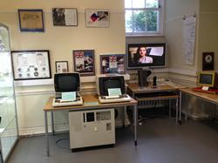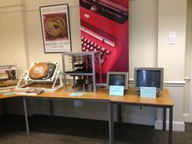

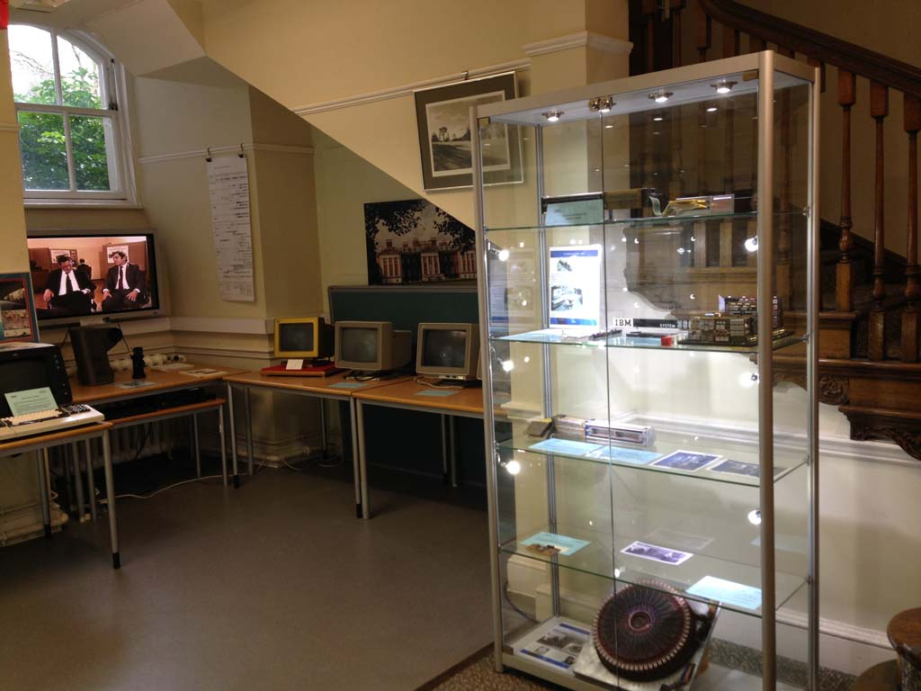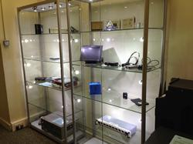

The area currently occupied by the PS/2 monitors in the lower left hand picture will be changed to accommodate items from the Emerging Technology Centre as a bridge from history to future.

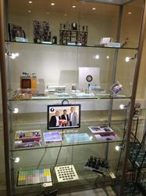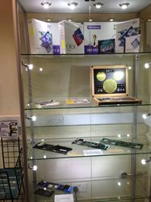

We have also managed to obtain a good range of new tools for the back office.

Electromatic Typewriter

One of our curators has managed to find an Electromatic typewriter in the U.S., and it is on its way. Electromatic was acquired by IBM in 1933, forming the beginnings of the company's typewriter business.

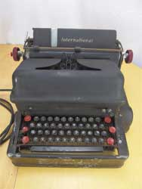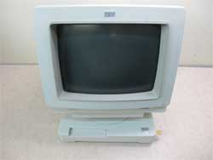

3179

We are also hoping to obtain a 3179 colour display terminal soon. This was the replacement for the 3279 Hursley-developed colour terminal. The overall product was designed in Fujisawa, although the monitor development was sub-contracted to Hursley.

Other

We have also continued to receive a number of other donations, including a PS/2 Model 55, Lexmark printer, flat screen monitors, PC adapters and accessories, PC and PS/2 Technical Reference manuals and more.

Finally, where we have a good amount of information on a product, we will be replacing the information cards to include QR codes to that information. The first products are the 3101 and 3102, both from Fujisawa. I was heavily involved in the service planning for these and other terminals, including the 3179.

